Fundamentals of Software Design Unit 3

David Finger

Colorado Technical University

Abstract

Identify design principles, architectural styles, key use cases from a website for reverse engineering. Show a UML diagram for the packages within the architectural style.

Design Principles:

1. Single Responsibility Principle
   1. Amazon.com uses Single Responsibility Principle multiple times in its overall construction. Each portion of the website is sectioned out to display single modules that are groups of things that all share a common link. These links can be things that can be delivered today, things that you might like based on your shopping in the past, and things that you have recently viewed (Archiveddocs, chapter 2).

1. Principle of Least Knowledge (also known as the Law of Demeter)
   1. Amazon.com uses the Principle of Least Knowledge when viewing individual items on its website. Each item listed has its own information sheet with information that is specific to only that item. These sheets cover everything from who produces the item, the item model number, the dimensions of the item, as well as warranty information (Archiveddocs, Chapter 2).

Architectural styles:

1. Object-Oriented Architecture
   1. Amazon.com utilizes Object-Oriented Architecture in the way that it handles transactions and inventory on its website. Each Item that is added to the website creates a new Object that can be added to and manipulated by either the users, when placing orders, or the employee teams, when adding stock or removing old objects. These Objects can also be linked together to form packages of similar objects that allows for easier searching and identification of Object sets (Archiveddocs, chapter 3).

1. Component-Based Architecture
   1. Amazon.com utilizes Component-Based Architecture in almost all the modules that it has active on its website. These modules are easily reusable and encapsulated to allow the background algorithms used by the website to display information based on the individual property assigned to that module. Examples include a module that shows information based on user profile, or recently viewed items, or displaying the deal of the day from the website (Archiveddocs, chapter 3).

Key Scenarios, Use Case Diagrams:

1. Searching of Products Use case
   1. A big portion of the usage of Amazon.com is the ability to lookup products and see in stock availability. Use case includes user and inventory systems (UML).

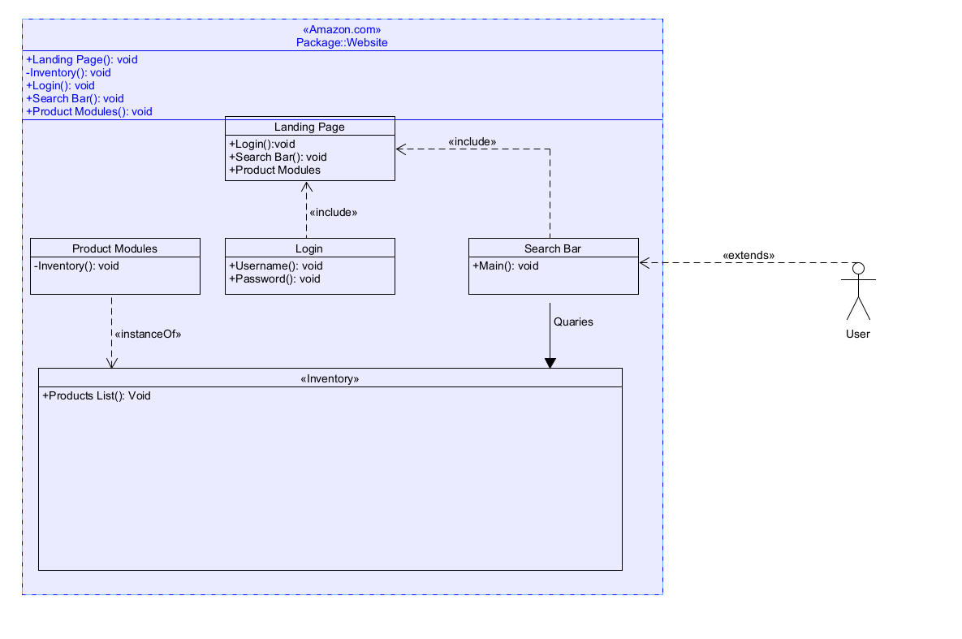

1. Tracking of purchased products
   1. The Tracking of purchased products is considered a critical function of the amazon business. Use case includes user and delivery service interaction (UML).

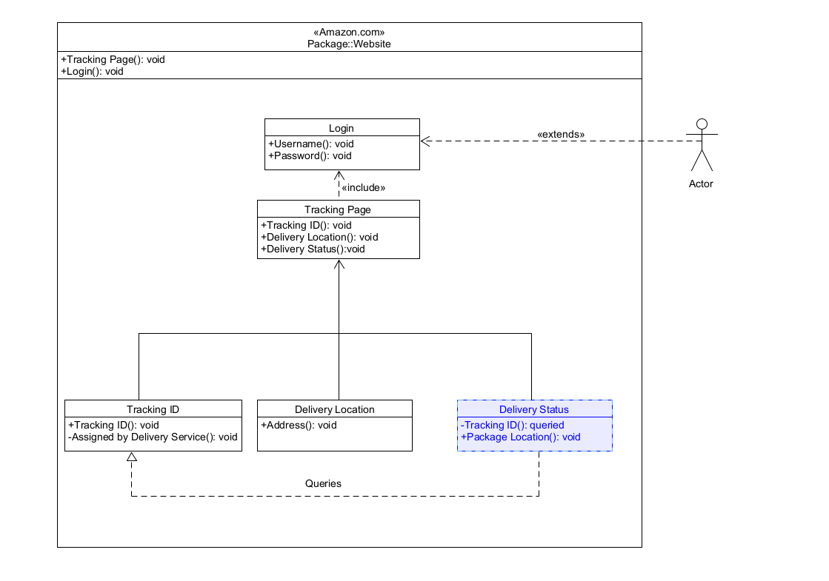

Logical Views of Architecture:

1. Amazon Website Landing Page
   1. Search bar
      1. Section Breakdown
   2. Login
      1. Username
      2. Password
   3. Navigation bar
      1. Trending
      2. Digital content
      3. Shop by department – Section Breakdown
      4. Programs and features
      5. Help and settings
   4. Product Modules
      1. Recently viewed
      2. Deal of the day
      3. Video splash
      4. Explore more items
      5. Purchase review
2. UML package Diagram

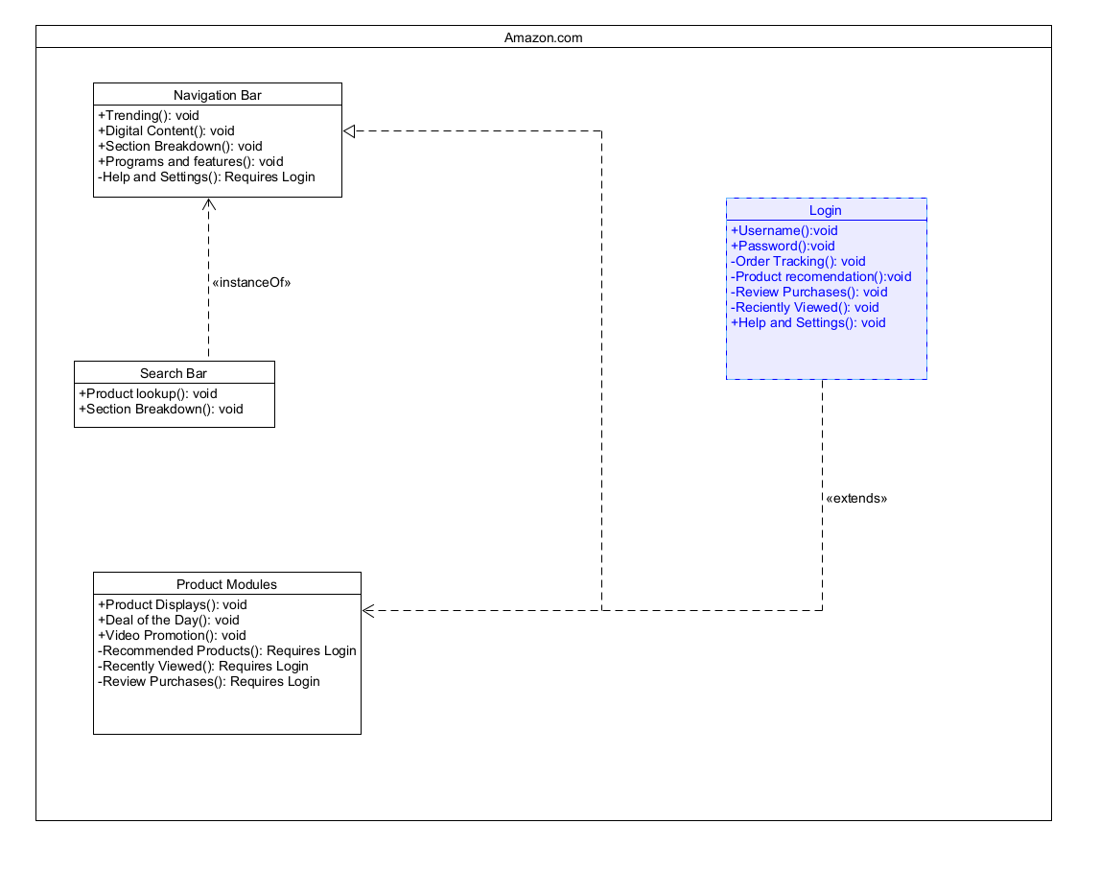

1. Each Component of the amazon website feeds off the other modules to make the user experience much more personalized and unique. Some features are locked behind the login system, such as product recommendations, recently viewed products, and the ability to review past purchases, but otherwise the general product modules displayed are based on majority user utilization. The search bar itself acts as an instance of the navigation bar minus a few logged in features. All product modules on the landing page also get more personalized upon login to the user account.

Component-level design for chosen package:

1. Login System
   1. Username
   2. Password
      1. Above Needed to access User Account, which allows access to components below.
   3. Help and Settings
   4. Product Recommendations
   5. Recently Viewed
   6. Orders
   7. Product Reviews

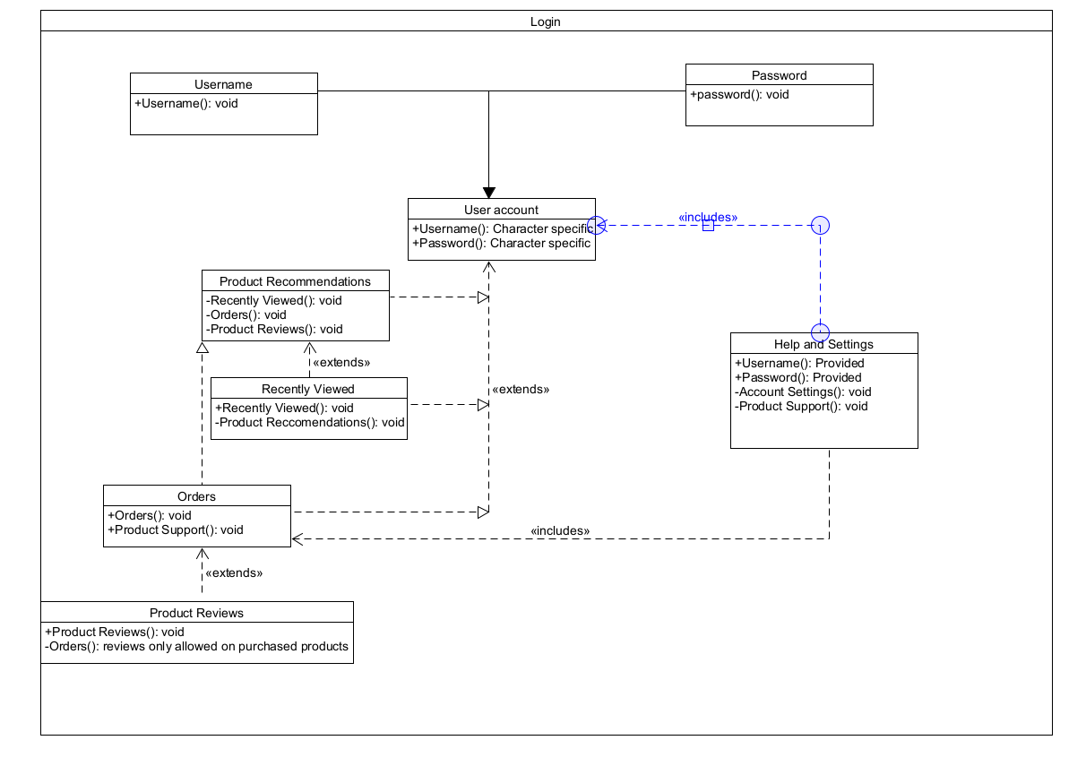

Resources

*Amazon.com: Online Shopping for Electronics, Apparel, Computers, Books, DVDs & more*. (n.d.). Retrieved April 19, 2021, from <https://www.amazon.com/>

Archiveddocs. (n.d.-a). *Chapter 2: Key Principles of Software Architecture*. Retrieved April 19, 2021, from <https://docs.microsoft.com/en-us/previous-versions/msp-n-p/ee658124(v=pandp.10)>

Archiveddocs. (n.d.-b). *Chapter 3: Architectural Patterns and Styles*. Retrieved April 19, 2021, from <https://docs.microsoft.com/en-us/previous-versions/msp-n-p/ee658117(v=pandp.10)>

Archiveddocs. (n.d.-c). *Chapter 4: A Technique for Architecture and Design*. Retrieved April 19, 2021, from <https://docs.microsoft.com/en-us/previous-versions/msp-n-p/ee658084(v=pandp.10)>

*UML package diagram—Bing images*. (n.d.). Retrieved April 19, 2021, from <https://www.bing.com/images/search?view=detailV2&ccid=atGAoGCM&id=AA202B737C001BCD7F45BA044B2FD9463547BDC1&thid=OIP.atGAoGCMsiCtEhD7-rGrEgHaGw&mediaurl=https%3a%2f%2fi.stack.imgur.com%2fm1YfS.png&cdnurl=https%3a%2f%2fth.bing.com%2fth%2fid%2fR6ad180a0608cb220ad1210fbfab1ab12%3frik%3dwb1HNUbZL0sEug%26pid%3dImgRaw&exph=822&expw=900&q=uml+package+diagram&simid=608051877528408427&ck=68BF533A4C66B229BDADB757E8174CF4&selectedIndex=0&FORM=IRPRST&idpp=overlayview&ajaxhist=0>